Blaise Johnson

Assignment 2.2- Debugging

Breakpoint set on line 18:

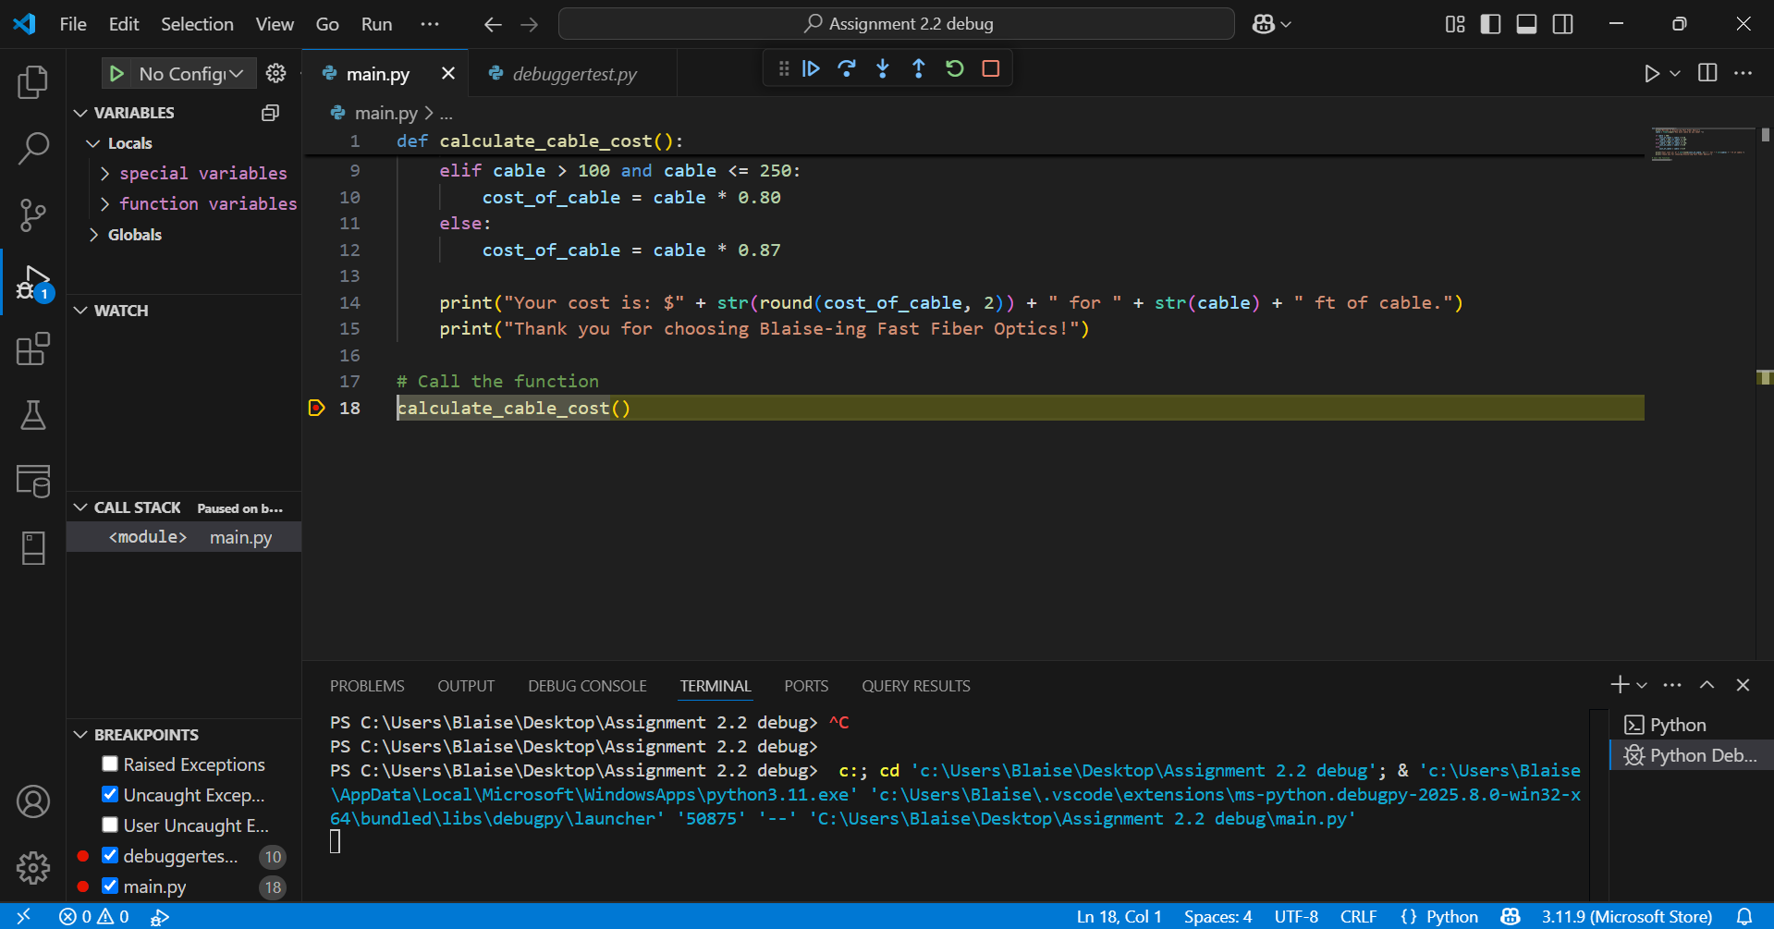

Step Into function on line 2:

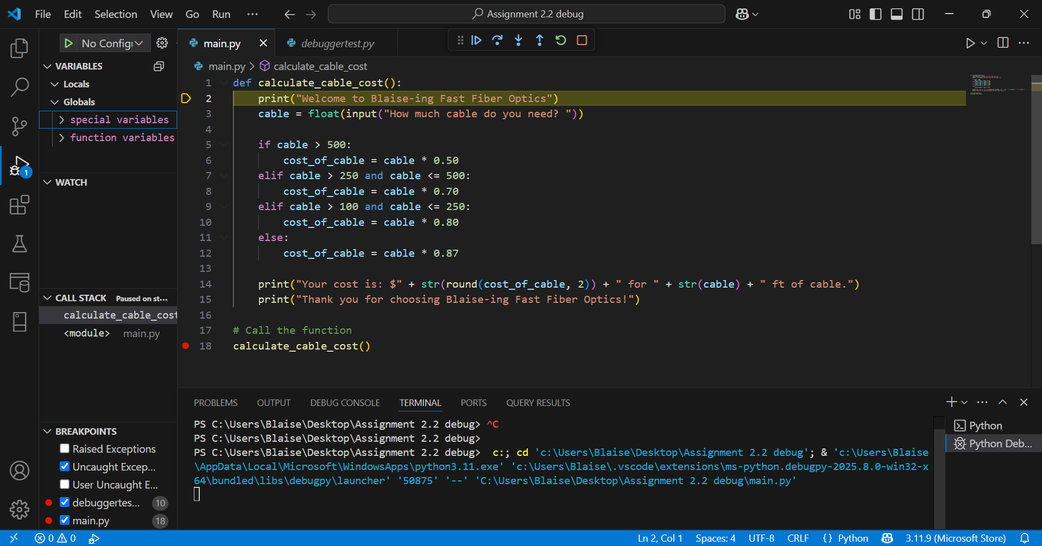

Implemented an error into code on line 14:

